Special Educational Needs Units – Frequently Asked Questions (FAQs)

Context

How do we know that more specialist provision places are needed in Suffolk?
In 2018 Suffolk County Council’s Special Educational Needs and Disabilities (SEND) Sufficiency Assessment highlighted a need for additional specialist places. From the Sufficiency Assessment a gap analysis was completed to identify new provision needed to establish a comprehensive local offer. Workshops and consultation on sufficiency findings took place and from this the Policy Development Panel made proposals for additional provision which were agreed by Suffolk County Council’s Cabinet. The SEND Capital Programme was introduced and separated into two phases. The first phase has created 825 new places so far, with 500 places already available and a further 325 due to open between September 2022 – September 2024. A significant number of these placements were met through specialist units attached to mainstream schools, which has enabled pupils to access mainstream education along with specialist support appropriate to their needs. In 2022 a review of the places delivered was undertaken and an updated sufficiency assessment was carried out. The 2022 SEND Sufficiency Plan has shaped phase 2 of the SEND Capital Transformation Programme.
What commitment has Suffolk County Council made to deliver additional specialist provision places?

Cabinet agreed to:

- Establish a new framework for the provision of specialist education in Suffolk with clear pathways of offer to meet a comprehensive range of needs.
- To invest in a capital programme to establish the specialist units and new special schools needed to make these pathways a reality.

What is the SEND pathway in Suffolk?

The ‘Suffolk Education Framework for Children and Young People with SEND’ has been developed to provide families and practitioners with a clear understanding of the Suffolk local offer. The Framework uses consistent language to describe specialist settings in Suffolk. Specialist provision in Suffolk will now follow four pathways;

• Communication and interaction
• Cognition and learning
• Social, emotional and mental health (SEMH)
• Sensory and/or physical needs

What new specialist provision was agreed at the start of Phase 1?

Pathway | Developments
Cognition and learning | Specialist units for KS2-4
Communication and interaction | Specialist units for KS2-4  2 Special schools in Ipswich & North Suffolk
SEMH | Special school in West Suffolk
Sensory | Hearing impaired resource base for KS3/4 serving East Suffolk

Other elements agreed:

- A network of specialist units for Key Stage 1 that cover all 4 pathways
- Development of Chalk Hill, Sudbury, as a specialist provision for children and young people with complex needs, including Autistic Spectrum Disorder and SEMH
- Development of new facilities for Pupil Referral Unit (PRU) provision for North Suffolk.

What new provision has been developed from Phase 1?
School | Area | Profile of Need | Key Stage | Open | Places
Castle EAST | North | Communication and Interaction | KS2 to KS4 | 2021/22 | 120
Sir Peter Hall | West | Social, Emotional and Mental Health | KS2/3 | 2022/23 | 80
Woodbridge Road Academy | South | Communication and Interaction | KS2 to KS4 | 2022/23 | 60
Chalk Hill | County Wide | Social, Emotional and Mental Health and Autism | TBC | TBC | 24
Unit | Area | Profile of Need | Key Stage | Open | Places
Beccles High | North | Cognition and Learning | KS3/4 | 2021/22 | 18
Bungay Hearing Resource Base | North | Resource Base for Children with Hearing Loss | KS3/4 | 2020/21 | 15
Oulton Broad | North | Specialist | R / KS1 | 2022/23 | 12
Pipers Vale | South | Specialist | R / KS1 | 2020/21 | 12
Rushmere | South | Specialist unit with expertise in Communication and Interaction | R / KS1 | 2020/21 | 15
Saxmundham | South | Cognition and Learning | KS3/4 | 2021/22 | 18
Chantry | South | Cognition and Learning | KS3/4 | 2021/22 | 18
Murrayfield | South | Communication and Interaction | KS2 | 2020/21 | 18
Causton | South | Communication and Interaction | KS2 | 2020/21 | 18
Woodhall | South | Communication and Interaction | KS2 | 2021/22 | 18
Copleston | South | Communication and Interaction | KS3/4 | 2021/22 | 18
Saxmundham | South | Communication and Interaction | KS3/4 | 2021/22 | 18
Burton End | West | Specialist | R / KS1 | 2020/21 | 12
Exning | West | Specialist | R / KS1 | 2021/22 | 12
St Edmunds | West | Specialist | R / KS1 | 2022/23 | 12
Clements | West | Cognition and Learning | KS2 | 2020/21 | 18
Castle Manor | West | Cognition and Learning | KS3/4 | 2020/21 | 18
St Edmunds | West | Cognition and Learning | KS2 | 2021/22 | 18
Mendlesham | West | Cognition and Learning | KS2 | 2021/22 | 18
Stowupland High | West | Cognition and Learning | KS3/4 | 2021/22 | 18
Houldsworth | West | Communication and Interaction | KS2 | 2020/21 | 18
Ixworth | West | Communication and Interaction | KS3/4 | 2020/21 | 18
Newmarket | West | Communication and Interaction | KS3/4 | 2020/21 | 18

What new provision has been developed from Phase 2?

Unit | Type of Unit | Number of Pupils | Locality
TBC | Cognition and Learning KS2 unit | 18-24 | North
Sybil Andrews | Cognition and Learning KS3/4 units | 18-24 | West
East Bergholt | Cognition and Learning KS3/4 units | 18-24 | South

Phase 2 will see these units open in September 2024.

What are the requirements for Phase 3?
The SEND Capital Programme was taken back to Cabinet in October 2022, Cabinet unanimously agreed to develop 8 new units for Social Emotional and Mental Health (SEMH) in Key Stage 2,3 and 4 split across Suffolk.
SEMH Specialist Units | North | South | West
KS2 | 1 | 2 | 1
KS3/4 | 1 | 2 | 1
We will create 2 new reception and key stage 1 specialist units. There is currently a reception and key stage 1 specialist unit with expertise in Communication and Interaction (C&I) in Ipswich. It is recommended that this is duplicated in both the West and the North.
C&I Specialist Units | North | West
R/KS1 | 1 | 1

What is the timeline for the development of these new units?
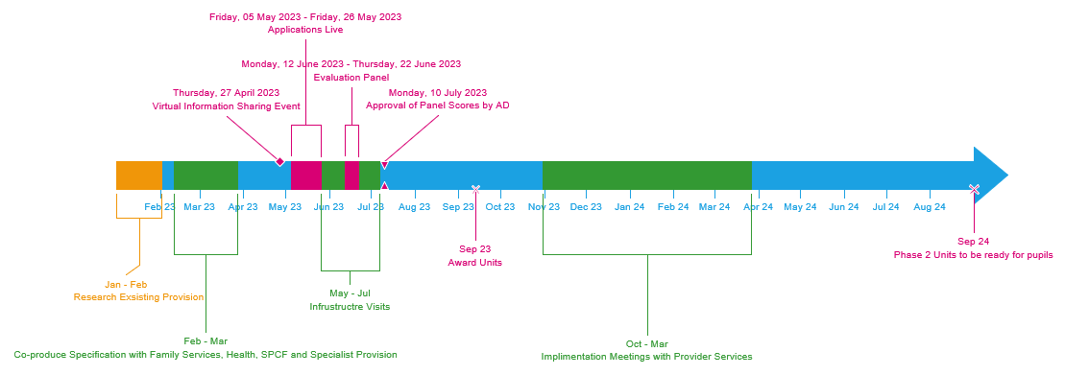

What is a Unit and how does it benefit young people?

A Unit is specialist education provision which is part of a mainstream school. Units provide a safe nurturing environment as a base for integration into mainstream education. Pupils may spend up to 50% of their time in the classrooms within the Unit. The Pupils are an integral part of the school and will benefit from being part of the wider School community. By attending provision closer to home, it will
will strengthen their roots in their local community enabling them to build strong local networks as they move towards adulthood. In addition, pupils will:

  - be on the roll of the school and the Headteacher will be responsible for their progress alongside all other pupils
  - be expected to participate fully in the life of the school, assemblies, after school clubs, drama, trips;
  - have access to all facilities of the school just like other pupils, including social areas and specialist teaching facilities such as sports hall, art and technology rooms and science labs;
  - participate in mainstream classes where they are able to – for example where a pupil has a specific strength or for a subject such as PE or art - where they can participate fully alongside their peers;
  - have a personalised curriculum offer;
  - be taught in smaller groups averaging 8 to 12, possibly as low as 6 where pupils need extensive support except where integration into mainstream classes is deemed appropriate.

What impact are the units having to the children and their families?
During the review of phase 1 of the capital programme, children attending the specialist units, parents/carers of children placed at the specialist unit and staff at the specialist unit were given the opportunity to share their views, please see below testimonials.
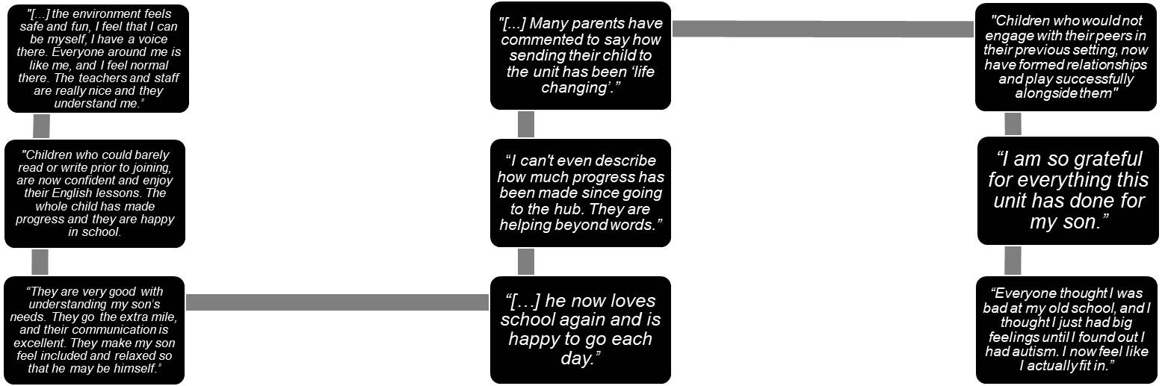

What are some of the wider benefits of having a Unit in a mainstream school?
Benefits to the wider school: evidence indicates that having a specialist offer as part of a mainstream school benefits the whole school community. All teachers have access to specialist knowledge and skills to support them in their classroom practice and pupils gain from being part of a fully inclusive community.
Ofsted and Performance Tables: the new Ofsted Framework encourages schools to make a more inclusive offer that meets the needs of their whole community. SCC’s Education and Learning Team is currently working with Ofsted and SSC colleagues to develop an approach to reporting outcomes for learners that supports inspectors to understand the context of a school with a unit.
Which children attend a Unit?

Pupils attending the Unit will have an identified need for a differentiated curriculum that cannot be met completely within a mainstream classroom environment. The table below demonstrates the increasing complexity of need and gives some context.

Step 1 | Step 2 | Step 3 | Step 4 | Step 5
Mainstream school with quality first teaching & personalised support | Mainstream school with support from specialist outreach services and/or additional specific measures | Specialist Unit attached to mainstream school | Specialist School within local area | Highly Specialist Independent School or school outside of the local area for low incidence high complexity need

What accommodation needs to be provided?

Suffolk County Council has developed a specification for the units. This is based on Building Bulletin (BB) 104 Guidance and must also be followed.

https://www.gov.uk/government/publications/area-guidelines-and-net-capacity

The space may be refurbished existing school capacity or a stand alone unit. During phase 1 of the programme a wealth of information was collated around making suitable spaces for pupils’ needs. Lessons learnt from previous projects are incorporated into future plans and designs.

Who will carry out the capital works?

For maintained schools, Suffolk County Council will carry out a feasibility study, commission and manage the works. Academies may manage their own projects but they will need to abide by the specification and obtain Landlord’s Consent from the County Council. Capital funding for academies carrying out their own work will be approved on a case by case basis and on receipt of three quotes for the work.
Academies conducting their own work will be required to sign terms and conditions before any capital grant monies are paid.

What statutory processes must be followed to allow a School to create a Unit?

This will differ for Maintained Schools and academies.

Maintained School Process

Suffolk County Council will lead on this process, but School’s must ensure that their Governors are supportive of the proposal before proceeding.

Academy Process

Academy trusts proposing to make a significant change which will affect clauses in their funding agreement, MUST submit a proposal for change, and follow the required process, in advance of the change being made. Failure to do so could constitute a breach of their funding agreement. This includes changes requested by the Local Authority (LA).
Proposals for change must be submitted to the Department for Education (DfE) through either a ‘fast track’ application or a ‘full business case’.

SCC will support academies to prepare the business case.

Will funding be available to the school to set up the provision?

Funding will be provided for staff time required to set up the Unit in the term prior to the Unit opening. An allowance of £5000 will also be made to help with classroom set up costs. Further details can be found in the SEND Growth Strategy the draft of which can be found below.

How will the pupils attending the Unit be funded?

Mainstream schools are funded for SEN units and resourced provision through:
- pre-16 core funding: a combination of per-pupil funding through the local schools funding formula, plus £6,000 per place for those occupied by pupils on roll and £10,000 per place for the remainder of places to be funded
- pre-16 top-up funding: agreed per pupil top-up paid by commissioning local authority
Further information is available through the High Needs Funding Operational Guidance.

High Needs Top-up Funding (paid by SCC)

Band | £ Funding
A | 0
B | 0
C | 1,500
D | 3,300
E | 5,500
F | 8,200
G | 10,500
H | 13,000
I | This is bespoke and therefore funding will be agreed greater than 16,000

Please see the Suffolk Learning website for further details
High Needs Funding – Suffolk Learning

Will a Service Level Agreement (SLA) be drawn up outlining the relationship between the School and Suffolk County Council for commissioned specialist education places?
Yes there is a Service Level Agreement which will be issued to schools where Suffolk County Council are commissioning places. Schools who are wishing to submit an expression of interest to host a specialist unit, will be given the opportunity to read the SLA prior to entering in the process to ensure they understand the expectations of the unit.
What is the longevity of the agreement – is there a notice period?
These agreements are permanent unless the terms and conditions of the SLA are breached. The Notice Period within the SLA is 6 months, following consultation.
Will children attending the Unit be part of the PAN?

No. Children attending the Unit are separate to the school’s PAN but they will be on the school roll. This means that the Headteacher and governors will have responsibility for pupil progress in the same way they do for all pupils on roll. There is a separate admissions process for the Unit.

If space which is surplus now in a school is used for a Unit and basic need in the local area grows, SCC will undertake to review the school’s capacity and agree together how demand will be met e.g. by another school, by an expansion of the existing school.

What will the admissions process be for pupils?

Admissions to specialist units will be made through Suffolk County Council’s specialist admissions process. Where a specialist placement within a unit is deemed appropriate for a child or young person, the specialist admissions team will send a consultation to the school(s) for their consideration.
Children who require ‘In Year’ admissions as a result of the Education, Health and Care Plan process will be considered throughout the year by the same process.
The Family Services Team will discuss the suitability of a placement for a child with the family and the school.
Further information will follow around specific admissions processes.

Does the LA commission all the places?
Yes, all admissions are managed through Suffolk County Council’s placement panels.
Can the number of places be increased or decreased and what is the mechanism?
Any requests for increase or decrease in numbers must come to the Suffolk County Council SEND Commissioning Team for approval. For Academies looking to increase SEND provision numbers by more than 20% a Business Case will need to be submitted to the Regional School’s Commissioner.
Will admissions be staggered on opening?

If staggered admissions are required we would look at this on a case by case basis, taking into consideration the specialism of the setting, the number of learners and the demand in the area.

How will parents/carers and other professionals know that they can apply for a unit?

The specialist admissions process is on the Local Offer website pages and all schools have been advised of how to access this. Parents/carers are not able to apply directly for a placement but any proposed admission will be discussed with them by the Family Services team.
If a School considers the placement inappropriate can admission be refused?
All admissions are managed through Suffolk County Council’s panels. It is through this process that the most appropriate placement for a student is found. Schools are able to respond to consultations via this process stating that they have identified that the school is unsuitable for the child for either of the following reasons:
- it would be unsuitable for the age, ability, aptitude or SEN of the child or young person, or
- the attendance of the child or young person there would be incompatible with the efficient education of others, or the efficient use of resources

Consult responses will be considered carefully by Suffolk County Council. As stated within the SEND Code of Practice, an LA can name the placement within section of I and the setting named MUST take the child, therefore the decision on admissions into specialist placements remains with Suffolk County Council.
What is the application process for children moving between Key Stages if they are attending a Unit?
This would be following an annual review of the child’s EHCP. If a new setting is required due to the current unit not catering for that Key Stage then this is referred and discussed via the specialist admissions process to identify a new setting.
If our School already has a child that we believe would benefit from the Unit in our School what is the admissions process for them to attend the Unit?
If they are currently in a mainstream setting, they should be referred through the specialist admissions process following an annual review of their EHCP. If they are being taught in a commissioned temporary small group, we will identify them as possible admissions and include them in planning for the new units.
When and how will pupils transition into a Mainstream School place?
Specialist units attached to mainstream schools are permanent specialist placements. If a child is placed in a unit by Suffolk County Council, then it has been identified that specialist provision is required. There will be some occasions where a child makes significant progress whilst being educated and supported within a unit, that it is felt by all working with the child that they would benefit from re-integrating fully into mainstream provision.
If this is the case, we would expect the setting to decide in conjunction with the Local Authority (Family Services) when the child is ready to move into mainstream education, however this would not necessarily be at the school where the Unit is located as they are most likely to return to their local school. If a child is ready to move back into mainstream, the parents will express a preference of school and the LA will consult with the setting regarding the suitability of the school to meet the educational needs. If this is not the child’s local school the LA will also consult with this school. If the school named in the EHCP is not the nearest then the responsibility for providing transport is the parent’s and not the LA’s, as it is the parental preference. Once a school has been identified in the EHCP we would expect the Unit to work with the mainstream school to support the transition and ensure the school is ready for the admission.
What staffing structure needs to be in place for the Unit?
Schools are free to determine their own staffing structure. However, it would be appropriate for the Unit to be overseen by the School SENCo, or if this is not possible, then by another member of the Senior Leadership Team. Each unit is likely to need 1 Qualified Teacher for approximately every 12 children and 2/3 Teaching Assistants.

Staff will need suitable experience of supporting children with SEND. This may include specific training.

Who will be responsible for staffing and recruitment?

Schools will be responsible for recruiting appropriate staff to work in the Unit. Staff working in the Unit will be managed as part of the school’s overall staffing structure.

How can I find out more?
Provider Services have held virtual information sessions for the SEMH and C&I Units. If you would like more information, please email ProviderServices@suffolk.gov.uk

